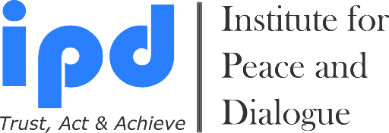
School of Human Recourses Management, Project Management & Conflict Resolution

We bring together Academicians, State, Private and Public Sectors

3 Month Executive Diploma Program 2026

APPLICATION

- Early Bird Application Deadline for Summer Intake: 10 February, 2026
- Late Application Deadline for Summer Intake: 31 March, 2026

- Early Bird Application Deadline for Winter Intake: 5 June, 2026
- Late Application Deadline for Winter Intake: 11 August, 2026

On-Campus or Online

Desired Diploma Program Modul

- Diploma in Conflicts Management & Mediation (CMM) Yes
- Diploma in Project Management (PM) Yes
- Diploma in Leadership & Human Resources Management (LHRM) Yes

- I would like to join both of the Diploma Programs Yes
If yes please specify which Diploma Program you wish to start in Summer and which Diploma Program you wish to stat in Winter?

Diploma Program Starting Time & Participation Type

- I wish to join Summer Intake: 1.06.2026 - 31.08.2026 Yes
- I wish to join Winter Intake: 1.10.2026 - 24.12.2026 Yes
- I want to join On Campus Classes Yes
- I want to join Online Classes Yes

Personal Details

1. Name:
2. Surname:
3. Nationality:
4. Date of birth (dd.mm.yy):
5. Passport number:
6. Date of expire (dd.mm.yy):
7. Post address: (country, city, region, district, house, street, apart., zip code and etc.)
8. Office & Personal E-mail:
9. Cell number / WhatsApp (Please send invitation):
10. Skype, Facebook & LinkedIn addresses (Please send invitation):

11. Name of your Work or Study Place (If available):
12. Contacts of your Organization (Full address, email, web page, tel. & fax) & Reference Person (If available):
13. Relevant Embassy contacts: (E-mail address which we need to send invitation letter for visa process)
14. How did you hear about 3 Month Executive Diploma Programs?
15. How you will cover your participation fee amount?
- Myself Yes
- My work or study place Yes
- Family member Yes
- Friend or Colleague Yes
- Other Sources (Please specify) Yes

Education

Name & Email of University | Length of Studies  mm/yyyy - mm/yyyy | Degree Obtained  (For example: MA in Political Science)

Participation at the Training, Seminars and Other Programs

Year | Country | Organizer’ name & email | Topic

Work Experience

Date:  mm/yyyy - mm/yyyy | Country | Name & Email of Company/Organization | Title of Position

English Language Skills

 | Speaking | Writing | Reading
Good
Excellent

Motivation & Expectations: (Not more than 500 words)

Please Select Your Study Type Expenses & Reductions

On Campus Classes Fees per Diploma Program: 48 Hours
- Early Bird Application Fee: 5200EUR Yes
- Late Application Fee: 6600EUR Yes

Online Classes Fees per Diploma Program: 30 Hours
- Early Bird Application Fee: 3600EUR Yes
- Late Application Fee: 4200EUR Yes

- I want Furnished Single Room Accommodation Yes
If YES then please inform us for how long period you wish to book accommodation via IPD?
_____ Month

- I am currently student (10% discount, please attach Reference Letter from University) Yes
- I am working for NGO (10% discount) Yes
- I am Alumni of IPD programs (10% discount) Yes
- I am paying together with group of participants (More than 2 person for 10% discount) Yes
- I am ProPeace Member (10% discount available): For registration please visit www.ipdinstitute.ch)
Yes

Application Deadline & Admission Procedure Step by Step

Interested participants need to send the filled application in WORD format as well as a CV and scanned Passport Page (Only photo page) by email to fhuseynli@ipdinstitute.ch no later than Application Deadlines. Please label your documents as “NAME” “SURNAME” “COUNTRY” “DOCUMENT NAME”.

1. The participant submits a filled application in WORD format with a CV and scanned passport page by the deadline
2. The participant will receive an invoice to start the payment of the requested participation fee amount
3. When the requested fee has been transferred to the bank account provided, the participant will receive an invitation letter via email. If visa application process is required, we will send the invitation letter by email to the relevant embassy.

NOTE: We strongly advice participants to submit the filled application as soon as possible, particularly if they require a visa to enter Switzerland or those who are and who in need of more financial documentation for his/her education.

Cancellation Rules & Procedure

Please note that after submission of the application in any case of the participation cancellation till the
- Minimum 20 calendar days before the program starts there will be 50% cancellation fee amount of paid participation fee + bank transfer and exchange rates costs will be extra charge
- 10 - 19 calendar days before the program starts there will be 80% cancellation fee amount of paid participation fee + bank transfer and exchange rates costs will be extra charge
- 9 calendar days before the program starts there will be no refund from paid participation fee.
Participant responsible to inform IPD directly by email or post about his/her participation cancellation.

Bank Account Information

Beneficiary`s Name: Institute for Peace and Dialogue (IPD)
Bank Name: PostFinance Ltd
Bank Address: Mingerstrasse 20, 3030 Bern, Switzerland
Account number: 91-577724-2 EUR
IBAN: CH 27 0900 0000 9157 7724 2
SWIFT code: POFICHBEXXX

Declaration of the Applicant

By submitting this Application Form I confirm that all the information given in this form is correct, true and complete. I also confirm that I agree to the following conditions of participation:

Yes I will actively join all the classes during the 3 Month Executive Diploma Program.
Yes I understand that the organiser reserves the right to exclude the participant from the course in case information given in the form proves to be incorrect or because of misconduct at the 3 Month Executive Diploma Program.
Yes I confirm that I don’t have refusal on using my photos in IPD promotional materials and website.
Yes I confirm the participation cancellation rules & conditions.

Name & Surname:

Date/Place: ______________________

Contact person for any questions:

Mr. Fakhrinur Huseynli
Director
Institute for Peace and Dialogue (IPD)
Address: Ryffstrasse 23, 4056 Basel, Switzerland
Cell number / WhatsApp: +41 76 431 61 70
E: fhuseynli@ipdinstitute.ch
www.ipdinstitute.ch
LinkedIn Profile: https://www.linkedin.com/in/fakhrinur-huseynli-574776223/

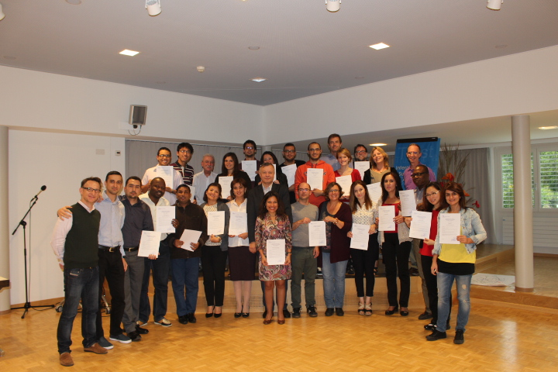
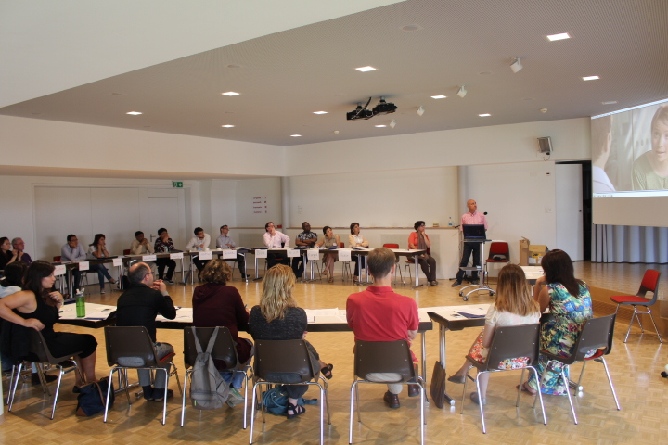

We are looking forward to receive your application soon and welcome you in our
3 Month Executive Diploma Program

